**Section 1:**

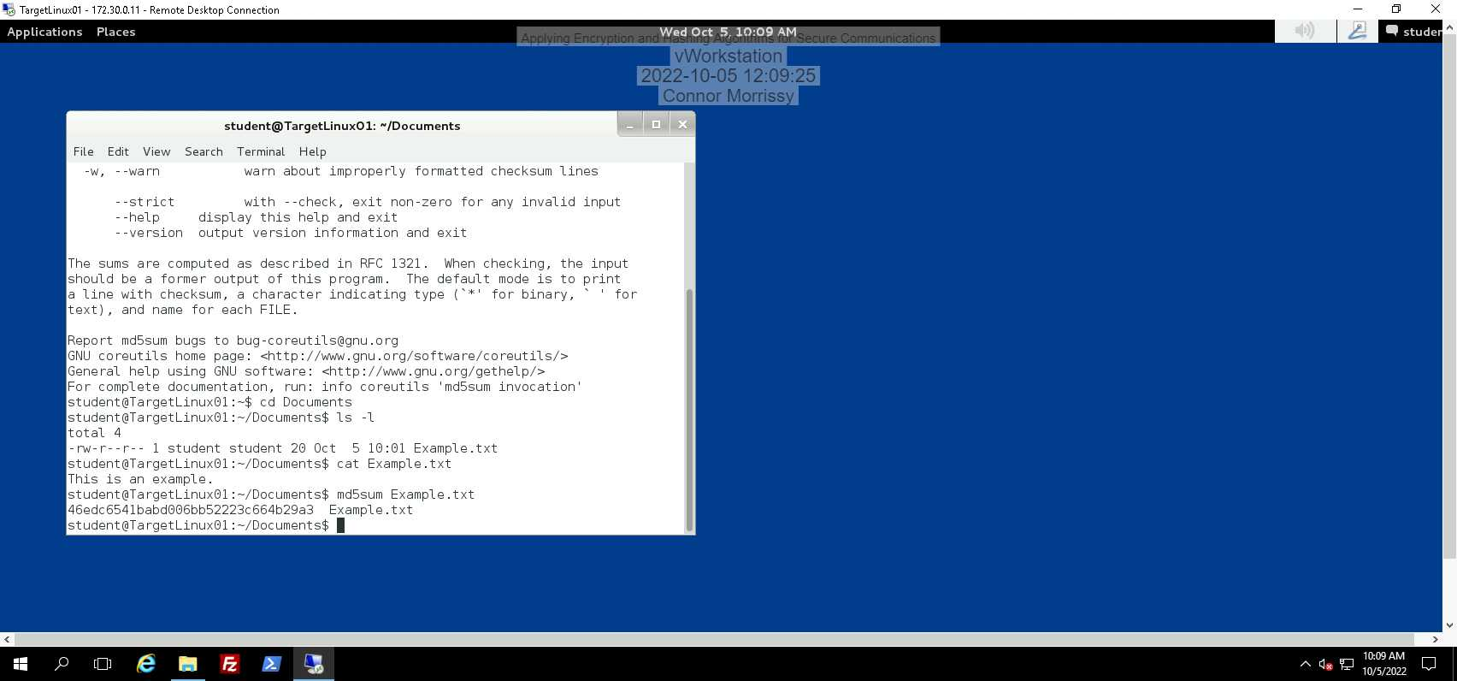

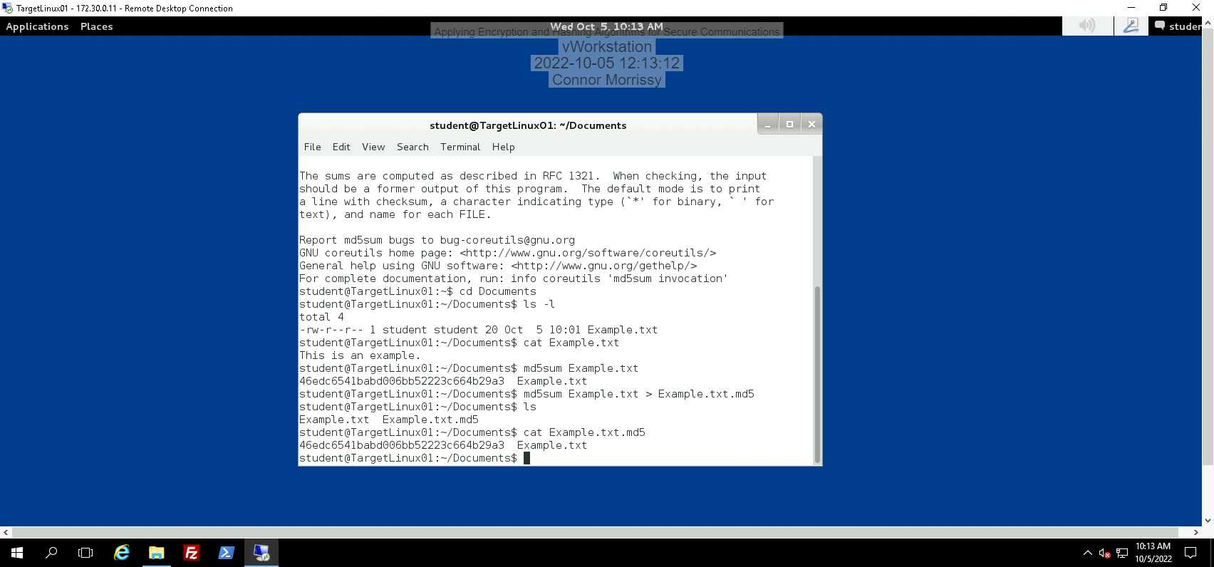

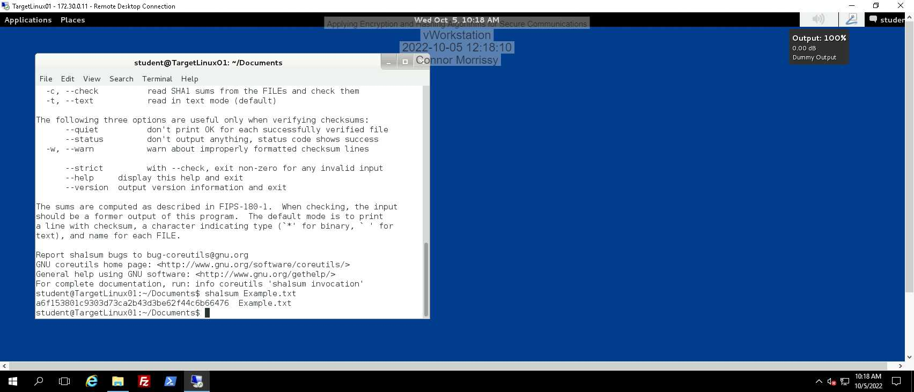

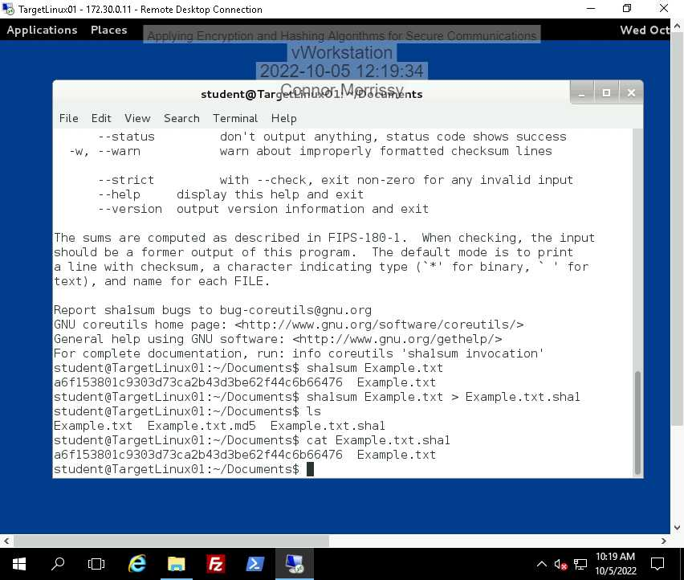

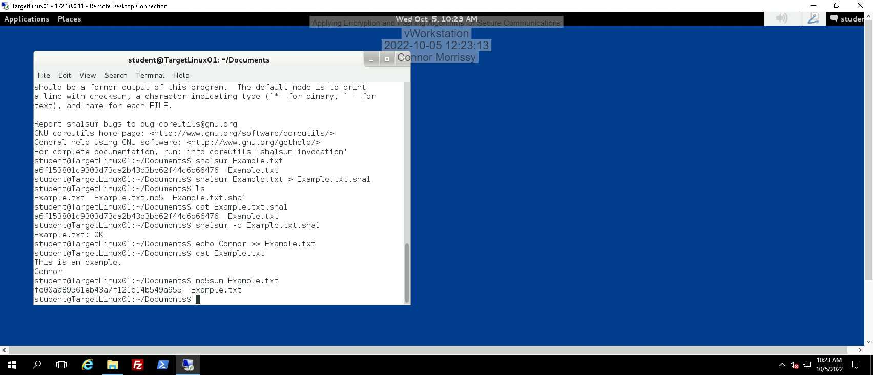

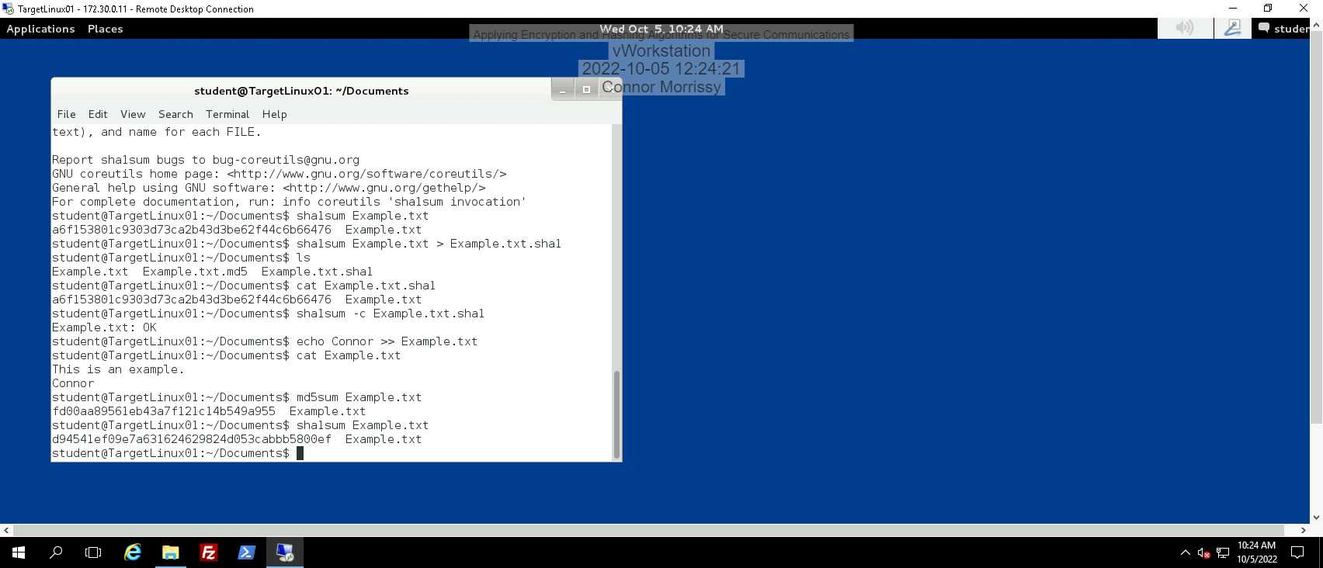

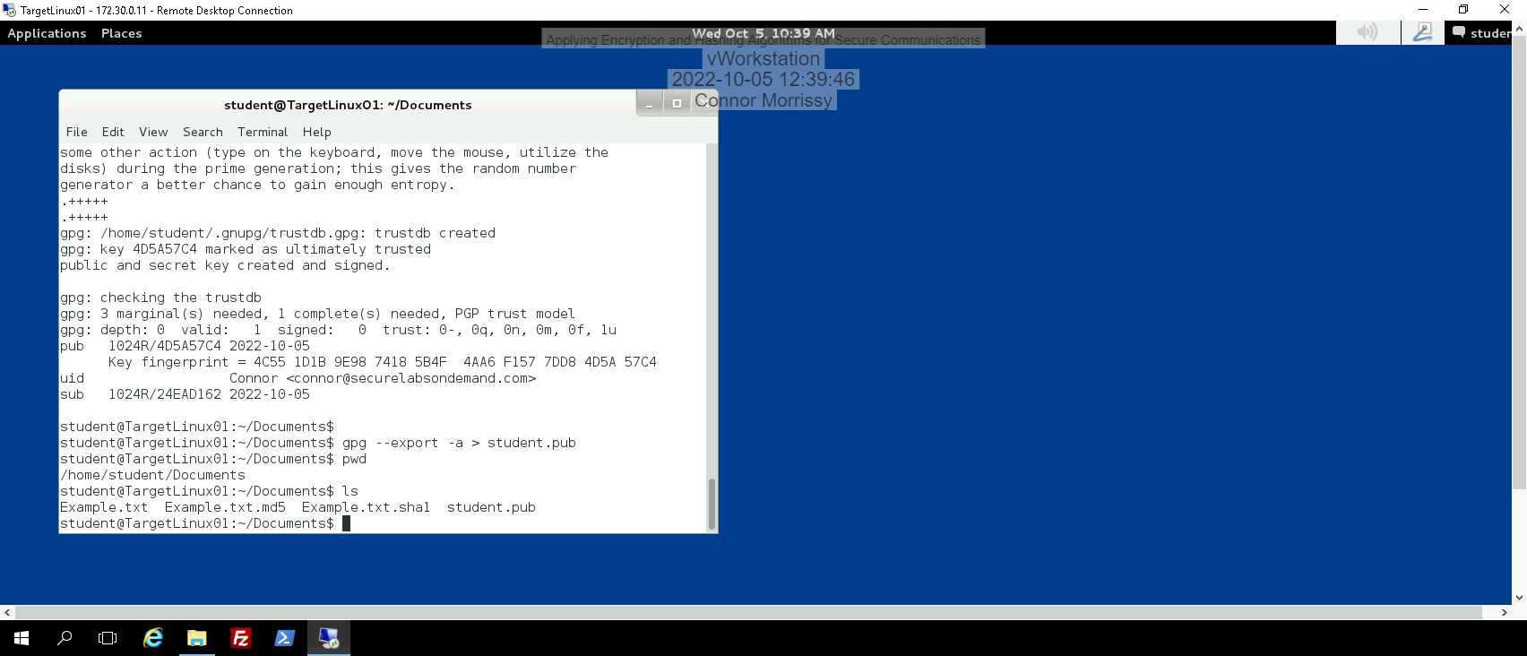

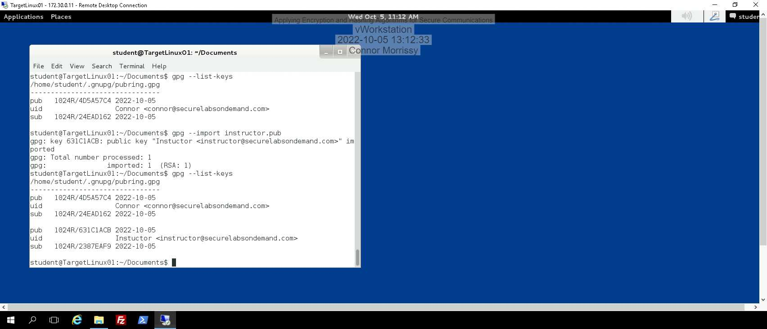

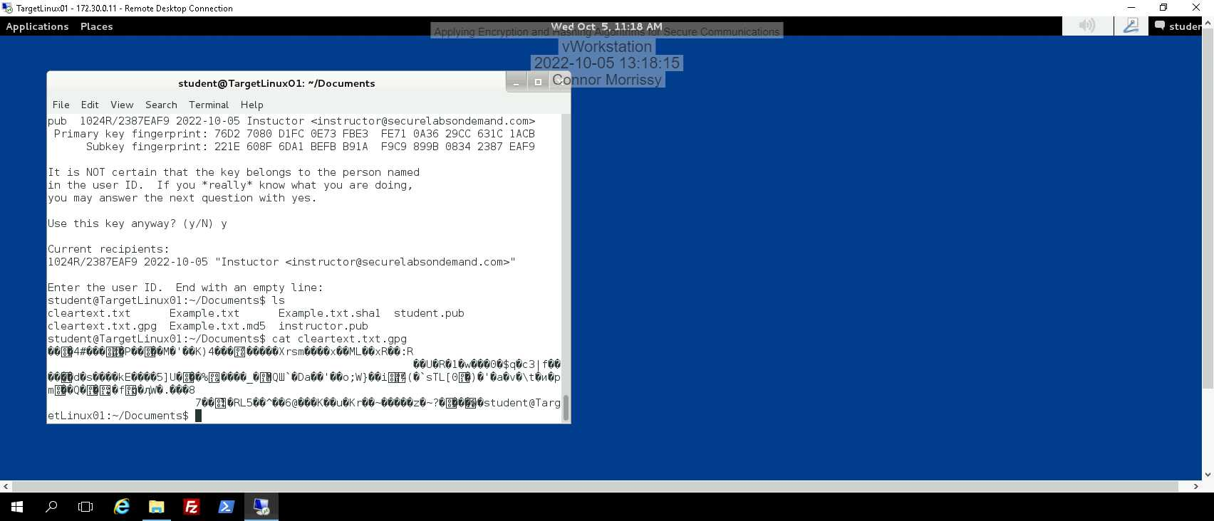

**Section 2:**

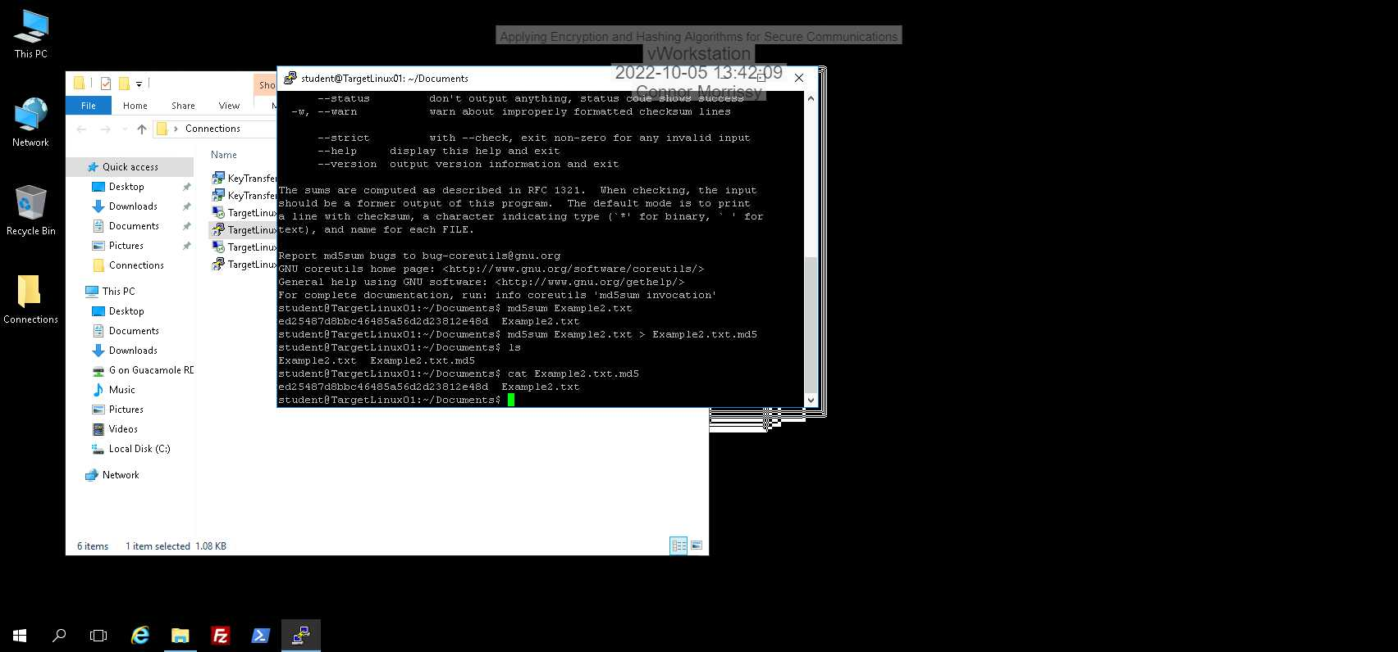

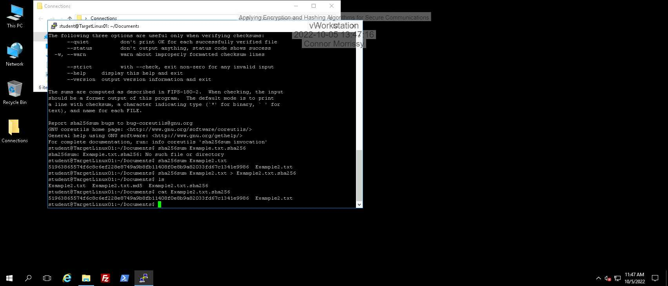

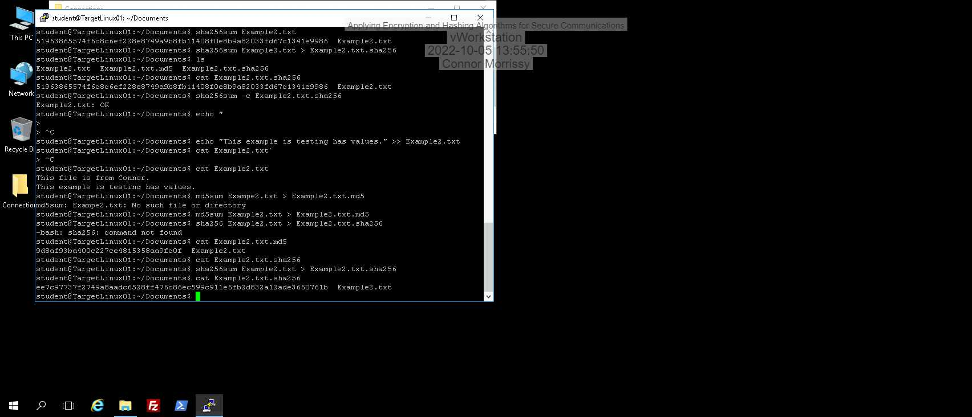

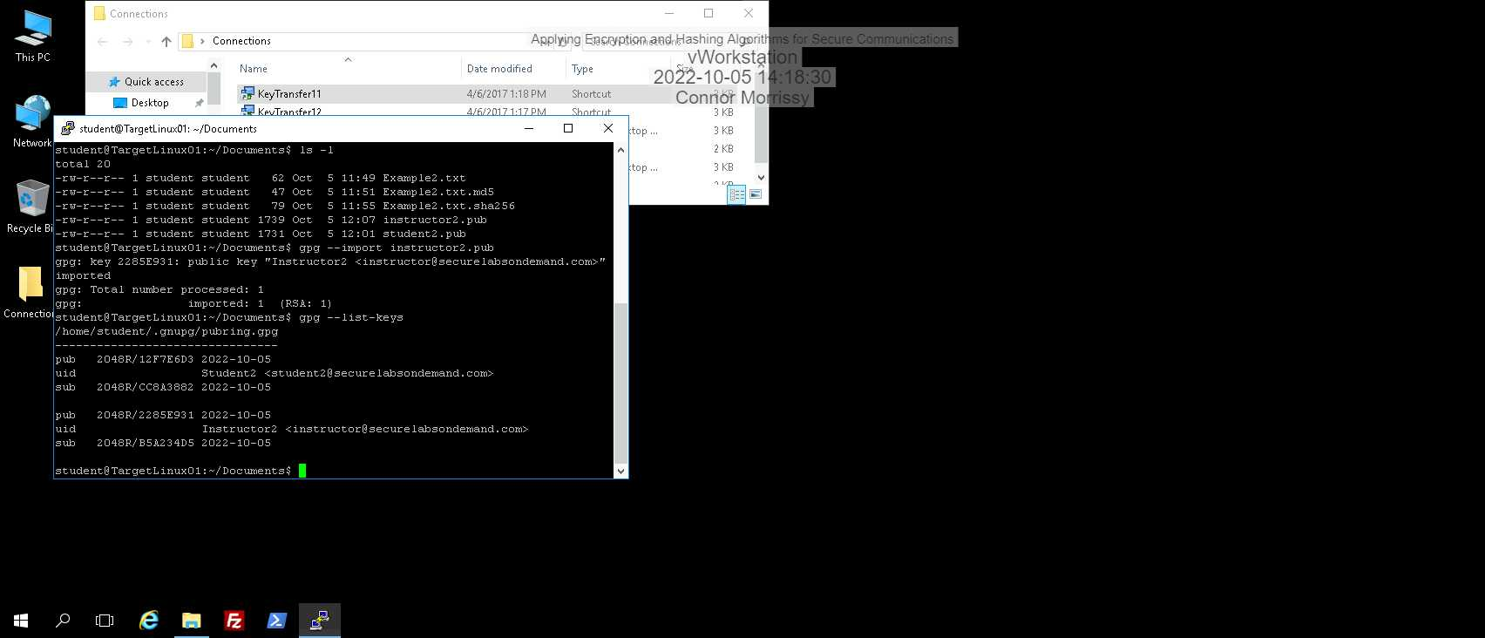

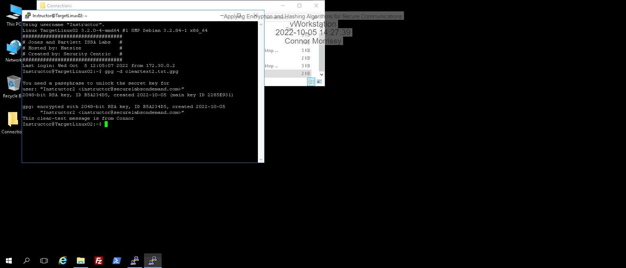

**Section 3:**

1. In the lab, you used RSA encryption, but there are other encryption algorithms. Describe the differences between RSA and ECDSA encryption algorithms, and name a well-known product that uses each type of encryption. Cite your references.

RSA encryption has been around and has been an industry standard for a long time. ECDSA on the other hand, is relatively new and is still being adopted. The major difference is that the ECDSA algorithm creates the same amount of security while requiring less bits to do so. This means that systems that use ECDSA algorithms use less overhead to process the encryption compared to RSA, while still having the same amount of security. Theoretically, a system that uses RSA could be more secure and faster by using ECDSA encryption.

RSA is used in a large number of products that use encryption (for example, email) and ECDSA is still being adopted, but is used in products that focus on security encryption/decryption (such as Bitcoin).

Source: I read a little from this site <https://www.ssl.com/article/comparing-ecdsa-vs-rsa/> and used my own background knowledge.

1. 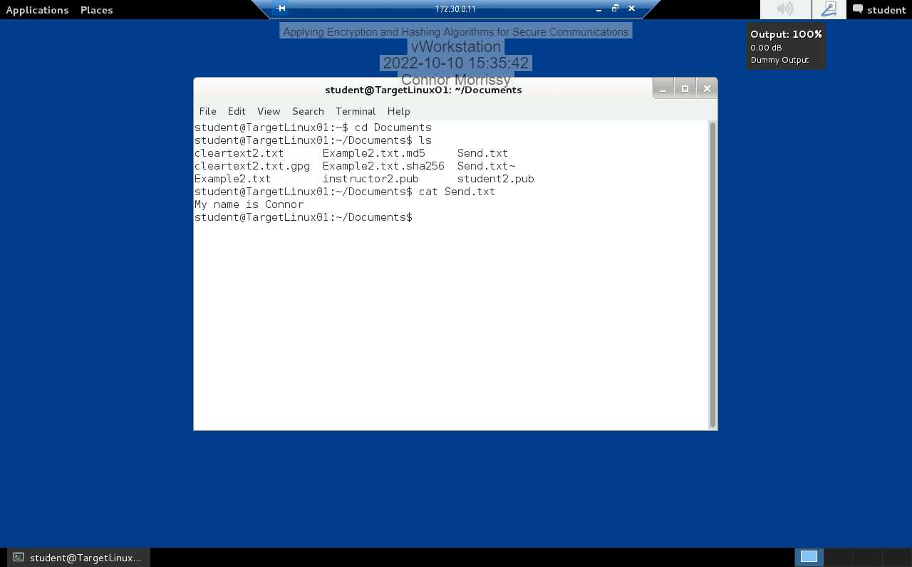a.

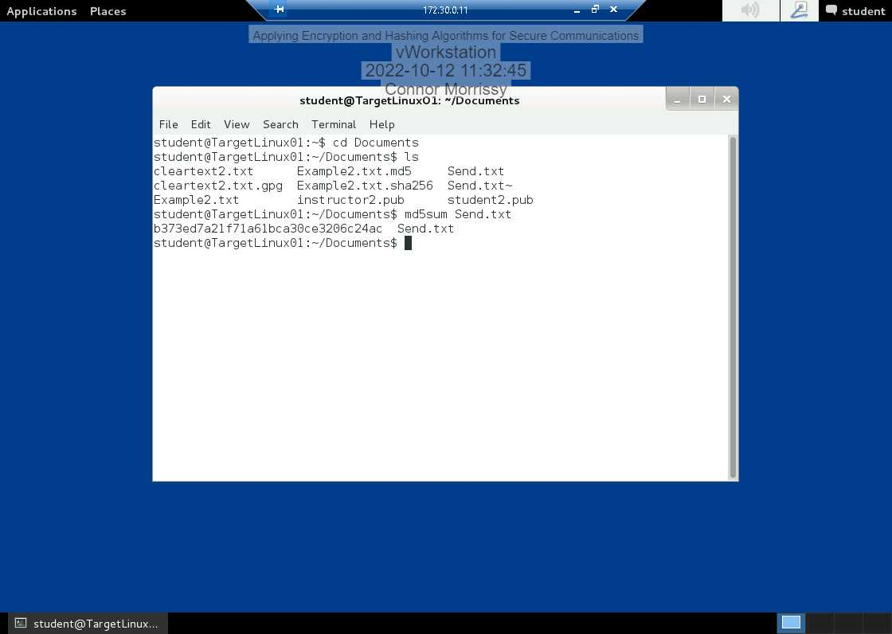 b.

Send.txt’s hash string: b373ed7a21f71a61bca30ce3206c24ac

c.

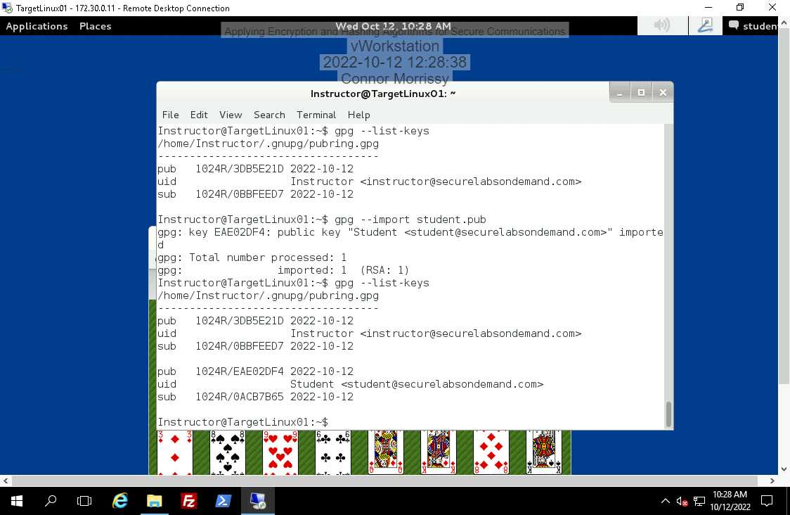

d.

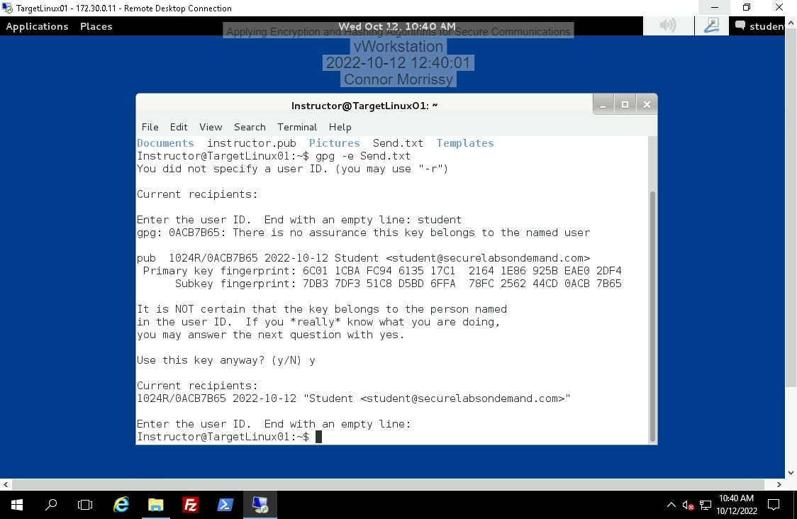

e.

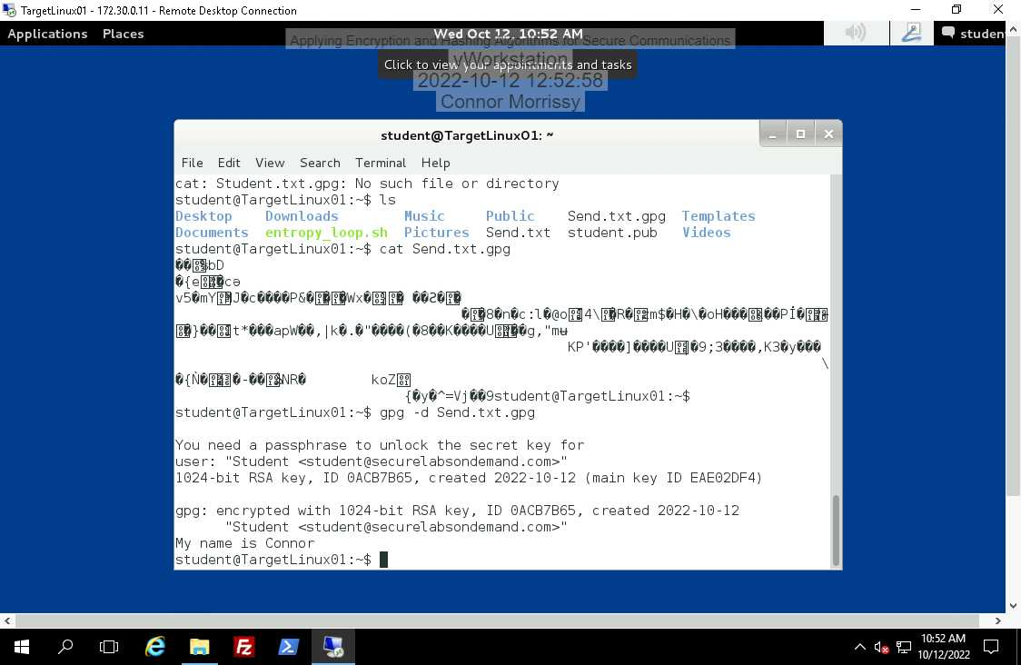s

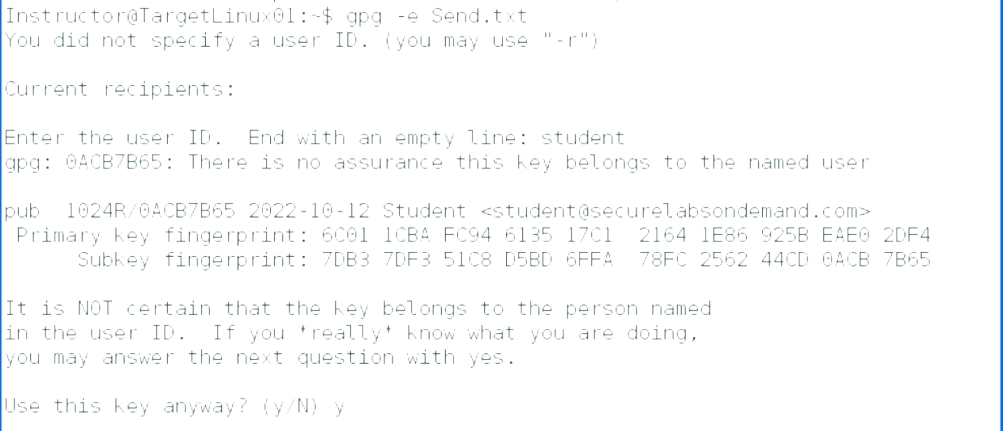 f.

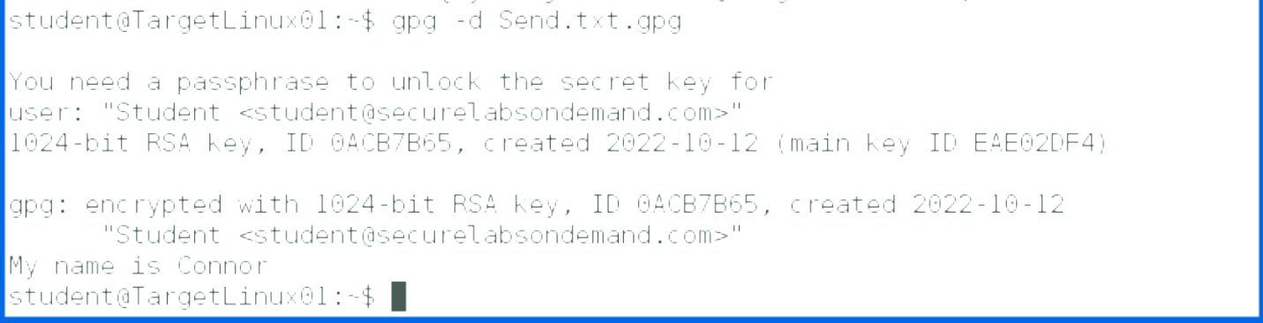

1. a.

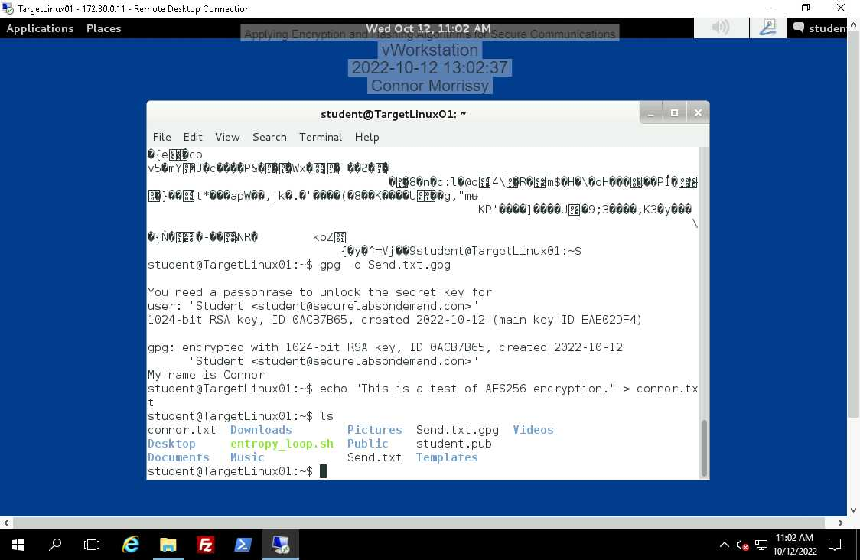

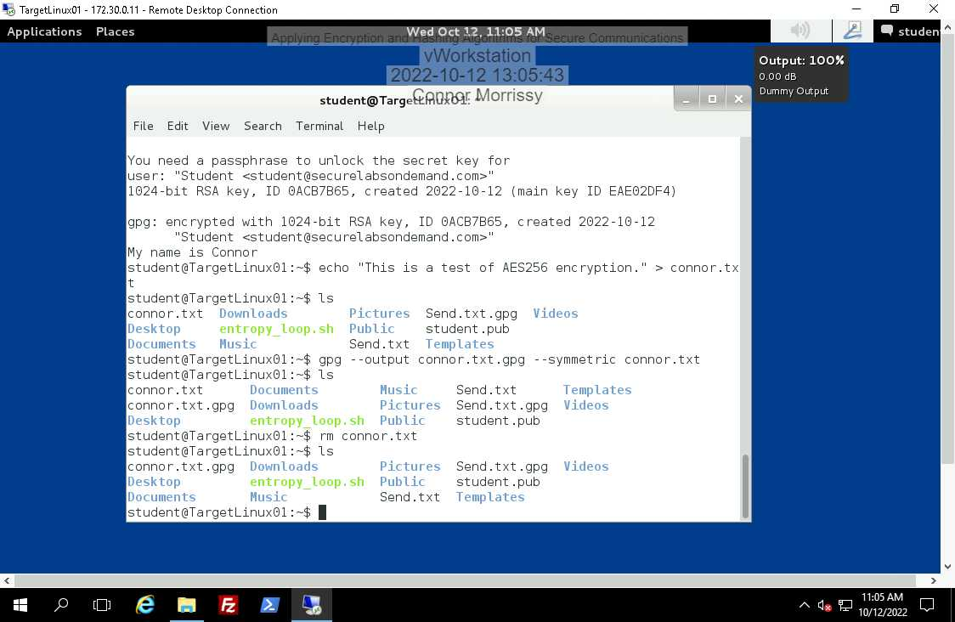b.

c.

c.

